Department | FED
Subject | DSA-2
Academic Year | I-III Semester(2025-26)
Faculty Name | BALAIAH SIR
Student Name | V.CHARISHMA
Roll Number | 2520030140
Branch | CSE
Course Outcome

Case Study Topic: Bangalore Metro Phase-3 Minimum-Cost Connection Plan using Kruskal's Algorithm
Work Done Summary:
- We analyzed a civil-engineering network optimization problem to connect 6 candidate metro stations {K, W, S, E, Y, H} back to the central hub M (Majestic).
- We mapped the 12-edge candidate infrastructure track graph where edge weights represent construction costs in ₹-crore.
- We executed Kruskal's Algorithm paired with a Union-Find (Disjoint-Set) data structure to systematically extract the Minimum Spanning Tree (MST).
- We traced the structural evolution of parent-pointers, evaluated cycles for each edge in sorted ascending order, and calculated the absolute minimum base connection cost.
- We verified network structural routing requirements against the regulatory redundancy mandate demanding multiple edge-disjoint paths.
Implementation Details
- Graph Representation: Programmed the 6-station track expansion layout using an Adjacency List containing all 12 candidate infrastructure edges with their respective construction costs in ₹-crore.
- Edge Processing: Sorted all candidate edges in ascending order and utilized a standard Min-Heap (Priority Queue) to systematically extract the lowest-cost track options first.
- Cycle Prevention: Implemented a Disjoint-Set (Union-Find) data structure with path compression to efficiently perform find and union operations, skipping any track edge that would create a closed loop.
- Redundancy Verification: Integrated a track validation script to verify the regulatory requirement of having at least two edge-disjoint paths between Majestic (M) and Whitefield (W).
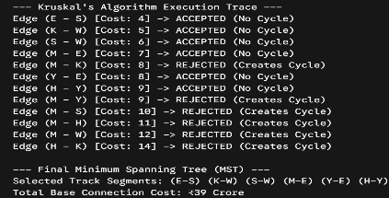
Results : Screenshots/Outputs
The application successfully identified 6 valid track segments—(E-S), (K-W), (S-W), (M-E), (Y-E), and (H-Y)—to establish complete connectivity at an absolute minimum cost of ₹39 Crore
